**Main Manuscript for**

**Power outages and cardiovascular and respiratory hospitalizations among US older adults**

**Heather McBrien1*, Daniel Mork2, Vivian Do1, Marianthi-Anna Kioumourtzoglou1, Joan A. Casey3,4**

**1 Columbia Mailman School of Public Health, Department of Environmental Health Sciences**

**2 Harvard T. H. Chan School of Public Health, Department of Biostatistics**

**3 University of Washington Department of Environmental and Occupational Health Sciences**

**4 University of Washington Department of Epidemiology**

**\* Corresponding author email:** [**hm2913@cumc.columbia.edu**](mailto:hm2913@cumc.columbia.edu)

**Competing Interest Statement:** The authors declare no competing interests.

**Keywords:** power outage, cardiovascular disease, respiratory disease, climate change, hospitalization

**Abstract:**

**Background**: In the United States, already-prevalent power outages are increasing in frequency and duration with climate change. Studies from New York State show that power outages may increase hospitalizations for cardiovascular (CVD) and respiratory disease in vulnerable populations such as older adults, but exposure data limitations have constrained nationwide studies of power outages and health.

**Question**: Are power outages associated with emergency CVD and respiratory disease-related hospitalizations among older adults in the United States?

**Methods**: We developed a national dataset of power outage exposure and identified county-days with ≥1% of customers exposed to 8+ hour power outages in 2018. We leveraged data on 23 million Medicare Fee-For-Service beneficiaries aged 65+ to estimate daily county-level rates of emergency CVD- and respiratory-related hospitalizations. We applied a case-crossover design with a conditional Poisson model to estimate the lagged association (up to 1 week) between daily county-level power outage exposure and cause-specific hospitalization rates. Models controlled for daily temperature, precipitation, and wind speed.

**Results**: Power outages were associated with increased emergency CVD and respiratory hospitalizations. The association between power outage and CVD hospitalizations was strongest the day after power outage exposure (rate ratio [RR]=1.02, 95% CI: 1.01, 1.03), while the association between outage and respiratory disease was strongest the day of power outage exposure (RR=1.03, 95% CI: 1.01, 1.04).

**Conclusion**: Power outages increase risk of CVD and respiratory hospitalizations among US older adults. Improving electricity reliability could support community health and protect older adults from CVD and respiratory disease exacerbations.

**Significance Statement:** Power outage frequency is increasing with climate change because of extreme temperatures, extreme weather, and wildfire-related power shutoffs. Outages pose serious risks to older adults’ health: heat and cold exposure and loss of power to medical and mobility devices following outages can cause hospitalizations. To study the health impacts of outages, we developed a national dataset of power outage exposure. With claims data from 23 million Medicare Fee-For-Service beneficiaries age 65+, we conducted a case-crossover study of daily county-level power outage exposure and cardiovascular and respiratory hospitalization rates. We found that power outage exposure was associated with increased hospitalizations for cardiovascular and respiratory disease. Our results suggest that improving electricity reliability could protect older adults from outage-related cardiorespiratory hospitalizations.

**Main Text**

**Introduction**

As the climate warms, the incidence and duration of power outages across the US are increasing (1). US electrical customers experienced an average of 8 hours without power in 2020—the longest duration on record (2). Aging electrical grid components, already at risk of failure, were not built to withstand previously rare extreme weather events now common with climate change (3, 4). 40-60% of major outages are now caused by severe weather events (5). Additionally, extreme heat and cold events will continue to increase electricity use to maintain indoor temperatures, outstripping supply and causing outages (6, 7).

Power outages threaten the health of vulnerable populations such as older adults (3, 8). Outages disable air conditioners and heaters and expose those affected to extreme temperatures (9). This heat and cold exposure may cause or exacerbate cardiovascular (CVD) and respiratory illness. Older adults are more likely to suffer health consequences from heat and cold exposure due to aging-related thermoregulation changes (10–12) and preexisting CVD or respiratory disease (13, 14). More than 70% of older adults live with CVD (15). Additionally, over 3% of older adults use electricity-dependent medical equipment such as ventilators and oxygen tanks at home to treat conditions like chronic obstructive pulmonary disease (3). For these individuals, loss of electricity can be directly life-threatening. Finally, prolonged loss of electricity to refrigerators, elevators, wheelchairs, and water supply or communication systems can result in stress, injury, dehydration, or isolation. Older adults’ increased reliance on mobility devices, elevators, and increased social isolation (16–18) may put them at higher risk than others for outage-related cardiovascular and respiratory illness.

Prior epidemiologic studies in New York State found elevated cardiovascular and respiratory emergency department visits up to one week after power outage exposure for all adults, as well as increased cardiovascular and respiratory hospitalizations and mortality (19–22).Associations may be stronger among older adults compared to younger adults (20). Population-level datasets of power outage exposure beyond New York State have only become available since 2020, limiting prior national-scale studies of power outage and health (3, 5, 23).

We previously assembled the first nationwide dataset of hourly county-level power outage exposure from 2018-2020 based on data from PowerOutage.us (5, 24). Here, we leveraged these data together with 2018 older adult Medicare Fee-For-Service hospitalization claims to estimate the relationship between daily county-level power outage exposure and cardiovascular and respiratory hospitalization rates in the United States in a case-crossover study. We evaluated the impacts of moderate and large-scale power outages and conducted secondary analyses examining effect measure modification by age, sex, Medicaid eligibility, and electricity-dependent durable medical equipment (DME) use.

**Results**

In this 2018 county-level case-crossover analysis, we used daily county-level counts of total urgent and emergency CVD and respiratory related hospitalizations and power outage exposure in a conditional Poisson model to estimate the association between power outage exposure and hospitalization rates up to 1 week later. We considered a county-day exposed to power outage if ≥1% of county customers were without power for 8 or more consecutive hours.

We included 2,161 US counties, covering 71.1% of older adult Medicare Fee-For-Service beneficiaries age 65+ (N = 23,645,101). These counties experienced an average of 7 (standard deviation, SD=29) 8+ hour power outages affecting ≥1% of customers in 2018 (**Figure 1**). The number of Medicare Fee-For-Service beneficiaries per county ranged from 8 to 252,004, and outages affecting ≥1% of county customers on average impacted ≥106 beneficiaries. 1.3% of county-person-days had a power outage (n=23,645,101 county-person-days) (**Table 1**). On average, more outages occurred on colder and windier days (**Supplemental Table 1)**.

The 2018 mean annual CVD hospitalization rate was 1,351 per 10,000 beneficiaries, and the respiratory rate was 805 per 10,000 beneficiaries (**Figure 1**). The most common causes of emergency CVD hospitalization were primary hypertension (I10), hypertensive heart and chronic kidney disease with heart failure (I30), and hypertensive heart disease with heart failure (I110). The most common causes of emergency respiratory hospitalization were acute respiratory failure with hypoxia (J96.01), acute COPD exacerbation (J44.1), and unspecified COPD (J44.9).

CVD hospitalizations

*Main analysis*

In our main analysis we used a case-crossover design with a conditional Poisson model to test the association between 8+ hour power outage and emergency CVD hospitalization rates up to 1 week after power outage exposure. We found increases in CVD-related hospitalizations 1-3 and 6 days after power outage exposure (**Figure 2**). Outage exposure was not associated with increased hospitalizations on other lag days. One day following power outage exposure, the CVD hospitalization rate was, on average, 2.0% (95% CI: 1.3%, 2.6%) higher compared to days after no exposure (**Supplemental Table 1**).

We also analyzed larger outages affecting ≥3% or ≥5% of county customers. Outages affecting ≥3% of county customers elevated next-day CVD hospitalization rates higher than outages affecting ≥1% of county customers (**Figure 2**). Outages affecting ≥5% of customers were associated with even higher next-day hospitalization rates compared to outages affecting ≥3% or ≥1% of county customers. For outages affecting ≥3% of county customers, the day after outage CVD rates were 2.7% (95% CI: 1.8%, 3.6%) higher than on days after no exposure. For outages affecting ≥5% of the population, rates were 3.1% (95% CI: 2.1%, 4.2%) higher than on days after no exposure.

*Sensitivity analyses*

Because there is no information on the health-relevant duration of power outages, we conducted sensitivity analyses evaluating the impact of 4+ and 12+ hour outages on CVD and respiratory hospitalization rates. For 4+ hour and 12+ hour outages, we observed similar results to 8+ hour outages. Hospitalizations were elevated on lag days 1-3 and 6. The effect estimates for 12+ hour outages on CVD hospitalizations were larger than for 8+ hour outages, and 8+ hour outage estimates were larger than 4+ hour outage effects (**Supplemental Figure 1**).

We also modeled the relationship between the continuous daily county-level number of hours without power and CVD hospitalization rates to test for a possible threshold effect where outages needed to last a certain duration to cause hospitalizations. We did not identify a threshold; the best-fitting model was linear for the association between number of hours without power and CVD hospitalizations. For every additional hour without power, the next-day CVD hospitalization rate increased by 0.1% and, therefore, by 2.4% for 24 hours without power (**Supplemental Figure 2**).

Respiratory hospitalizations

*Main analysis*

In our main analysis testing the effect of 8+ hour power outage exposure on emergency respiratory hospitalization rates, we found same-day increases in respiratory-related hospitalizations, as well as increases on lag days 1 and 2. In contrast to CVD hospitalizations, for respiratory-related hospitalizations, we observed the strongest association on the same day as the power outage rather than the day after. On the same day of power outage exposure, the respiratory hospitalization rate was 2.5% (95 % CI: 1.2%, 3.8%) higher than on unexposed days.

Outages affecting ≥3% of county customers resulted in stronger associations with same-day respiratory hospitalization rates than outages affecting ≥1% of county customers (**Figure 2**). Outages affecting ≥5% of customers were associated with even higher same-day respiratory hospitalization rates compared to outages affecting ≥3% or ≥1% of county customers. For outages affecting ≥3% and ≥5% of county customers, same-day respiratory hospitalization rates were 5.2% (95% CI: 3.4%, 7.1%) and 6.7% (95% CI: 4.6%, 8.9%) higher, respectively, compared to rates on unexposed days.

*Sensitivity analysis*

For sensitivity analyses evaluating the impact of 4+ and 12+ hour outages on respiratory hospitalizations, we found the strongest association for respiratory hospitalizations following 12+ hour outage exposure. Effect size increased from 4+ to 8+ to 12+ hour outage durations. Respiratory hospitalization rates were 1.2% higher (95% CI: 0.2%, 2.2%) the day of 4+ hour power outage exposure, 2.5% higher (95% CI: 1.2%, 3.8%) higher the day of 8+ hour outage exposure, and 3.2 times higher (95% CI: 1.7%, 4.6%) the day of 12+ hour outage exposure compared to unexposed days.

Finally, we modelled the relationship between continuous number of hours without power and respiratory hospitalization rates. Like CVD, the best-fitting model indicated a linear relationship between number of hours without power and respiratory hospitalizations. For every additional hour without power, the next-day respiratory hospitalization rate increased by 0.11% or 2.6% following 24 hours of power outage (**Supplemental Figure 2**).

Effect modification

We tested for effect modification of the relationship between power outage and CVD and respiratory hospitalizations by age, sex, dual-Medicaid eligibility, and percentage of county Medicare beneficiaries using DME. We used Medicaid eligibility as a proxy for poverty. Power outage exposure was distributed similarly across potential effect modifiers (**Table 1**). Overall, we did not observe effect modification by age, sex, or Medicaid eligibility.

For DME use, the association between power outages and respiratory hospitalizations appeared stronger in counties with smaller percentages of DME users (quartile 1 of DME use) compared to counties with larger percentages of DME users (quartile 4 of DME use). Respiratory hospitalizations remained elevated in counties with quartile 1 DME use for two days after power outage, while in counties with fourth quartile DME use, hospitalizations were elevated only on the day of power outage (**Figure 3**).

**Discussion**

In this 2018 case-crossover study of over 23 million Fee-For-Service Medicare beneficiaries aged 65+, we found that power outages were associated with increased acute emergency CVD and respiratory hospitalizations. This association was strongest for CVD hospitalizations the day following the power outage, while for respiratory hospitalizations, the same-day association was strongest. As expected, larger outages affecting ≥3% or ≥5% versus ≥1% of county customers had stronger associations with hospitalization rates. Furthermore, power outages were prevalent. US counties experienced an average of seven 8+ hour outages affecting ≥1% of customers in 2018, and shorter outages were even more common. With outage frequency and duration increasing due to climate change, these outages may pose a growing threat to the cardiovascular and respiratory health of older adults.

Several New York State-based studies have reported associations between power outage exposure and increased CVD and respiratory acute care visits, with larger effects for older versus younger adults (19–21, 25). As in our study, Deng et al. found the largest increases in CVD emergency department visits the day after exposure, while respiratory visits increased most on the day of exposure. Do et al. estimated the association of power outage with CVD hospitalizations in Medicare beneficiaries 65+ in New York State from 2017-2018, which overlaps our study period and population (25). They found elevated emergency CVD hospitalizations one day after power outage exposure, though confidence intervals contained the null. We estimated similar effects with more precision because of our larger study population.

We hypothesized that power outages may lead to CVD and respiratory hospitalizations in older adults due to increased heat exposure, cold exposure, stress, and loss of electricity to life-sustaining medical devices and mobility aids. Power outages may also cause changes in indoor air quality when dehumidifiers, air purifiers, and ventilation systems lose power. The lagged effects of CVD and respiratory hospitalizations due to power outage are likely different since the lagged effects of high or low temperature and air pollution differ for CVD versus respiratory disease (26–28).

Further, many power outages are caused by climate-related severe weather like heat waves, winter storms, hurricanes, wildfires, and floods (3, 29, 30), which likely amplifies health risks (20, 31, 32). While we did not directly assess co-exposure to extreme weather in this study, we controlled for temperature, wind, and precipitation as time-varying confounders. Enabled by new national datasets of power outage exposure (23, 24), future studies should examine the joint health effects of outages and severe weather, and test for effect modification by season and outdoor temperature.

In this study, larger outages affecting ≥3% or ≥5% versus ≥1% of county customers were associated with higher hospitalization rates. The reason may be two-fold. First, the effects of larger outages on hospitalization rates may appear stronger because the exposure is measured more accurately. We expect less exposure misclassification when ≥5% of county customers are without power compared to ≥1% of customers. Although the magnitude of bias is unknown, there is no reason to expect that exposure misclassification would be differential with respect to CVD and respiratory hospitalization rates. Any resulting bias, therefore, would be towards the null (33). Second, larger outages may also cause more hospitalizations because they are community-wide events (3, 32). During a small power outage, older adults may be able to rely on neighbors or other nearby community resources for social support, electricity, heat, or air conditioning. During a larger outage, fewer places have power, and fewer people can help. Therefore, more individuals may be exposed to the midstream effects of power outage such as heat and cold during these larger outages, potentially increasing hospitalizations.

Though some prior studies have described the health consequences of power outages, the duration of power outage that impacts health remains unknown. In our main analysis, we assessed exposure to 8+ hour power outages, and we conducted sensitivity analyses evaluating 4+ and 12+ hour outages, finding that longer outage durations were associated with higher hospitalization rates. We also modelled the relationship between the county-level number of hours without power and hospitalization rates, and tested for non-linearity that would indicate a threshold effect, i.e. an inflection point where outages longer than a certain duration started impacting hospitalization risk. We did not find evidence for a threshold. We found that even one-hour outages were associated with increased cardiovascular and respiratory hospitalizations, suggesting that even short outages can have substantial population health impacts, especially since shorter outages are much more prevalent.

Finally, we hypothesized that certain subgroups might have worse responses to power outage exposure and tested for effect modification by sex, age, Medicaid eligibility, and DME use. Contrary to our hypotheses, we did not observe effect modification by age, sex, or Medicaid eligibility.

We did observe effect modification by DME use quartile. Counties with higher prevalence of DME use (4th quartile DME use) had lower hospitalization rates after power outage exposure than counties with lower DME use (1st quartile). We hypothesized the opposite: that DME versus non-DME users would be more vulnerable to health effects from power outage. Several factors may explain these unexpected findings. First, power outages could cause more mortality among DME versus non-DME users, so mortality could act differentially as a competing risk for hospitalization in the DME user group. We are unable to test this directly as we do not have access to individual-level DME use data. Second, DME users may be more prepared for outages compared to non-DME users, with greater access to generators or backup batteries (34), though reports describing preparedness among vulnerable groups are mixed (35). Third, we measured county DME use based on how many Medicare beneficiaries used any type of DME, including wheelchairs, beds, oxygen equipment, ventilators, augmentative and alternative communication devices, and more. These users are not equally vulnerable during power outages; certain types of DME use could indicate better access to healthcare, higher adaptive capacity, or a higher likelihood of residence in skilled nursing facilities with backup power. Finally, due to data limitations, the counts used to generate our DME use quartiles are based on the full Medicare population, while only Medicare Fee-For-Service beneficiaries comprise our study population.

Study limitations

In this study, we measured county-level power outages since no national finer-resolution power outage exposure data are available. In our main analysis, we considered a county-day exposed to power outage if ≥1% of county customers were without power for 8+ consecutive hours, a definition that may have substantial exposure misclassification (up to 99% of customers may be unexposed). This misclassification likely biased study results towards the null, but the magnitude of bias remains unknown. When we assessed power outage exposure based on higher thresholds of customers (≥3%, ≥5%), scenarios with less exposure misclassification, we observed larger effect estimates. Future studies could collaborate with utilities to obtain finer-resolution power outage data or use satellite imagery to identify exact outage boundaries of long-duration outages lasting into the night (36, 37) to address these exposure assessment issues.

Next, power outages may be more common in high social vulnerability communities (5). If power outage exposure in our study was more common among more vulnerable older adults, the effects estimated here may be overestimates of the population-level effect.

Additionally, we assessed DME use as a potential effect modifier at the county level. Because counties are large and diverse, this likely impacted our ability to detect effect modification.

Further, we were unable to distinguish between planned and unplanned power outages, which may have different effects on hospitalizations.

Finally, the POUS dataset we used to assess exposure is missing substantial data. We excluded counties missing more than 50% of customer-hours in 2018 to balance generalizability and bias from missing data based on our prior simulation study (38). Many counties missing >50% of exposure data were rural with low customer counts, and clustered in certain geographic regions, limiting our ability to generalize to these populations. Other studies of power outages and health have found differential effects by urban or rural status, with larger-in-magnitude associations of outages and health in urban areas (25, 39).

Conclusion

In this first US-wide study of power outage exposure and health, we found that power outages were associated with increased acute CVD and respiratory hospitalization rates among 23 million older adult Medicare beneficiaries. Beneficiaries in our study experienced broad exposure: on average living in counties with seven 8+ hour power outages in 2018, a number likely to increase further with climate change. Heat, winter storms, or other climate-related weather events causing and co-occurring with power outages likely amplify cardiorespiratory health impacts and must be evaluated in future research. Improving electricity reliability represents a key opportunity to support community health and protect older adults from CVD and respiratory disease exacerbations.

**Materials and Methods**

Study population

Our study population included Medicare Fee-For-Service beneficiaries aged 65+ and enrolled for at least one month between January 1st, 2018, and December 31st, 2018. From the Medicare Beneficiary Summary File (MSBF), we obtained age, sex, Medicaid-eligibility status, and county of residence for all beneficiaries.

We used the Medicare Provider Analysis and Review (MEDPAR) file to access inpatient claims data on all hospitalizations in our study population in 2018, obtained from the Centers for Medicare and Medicaid Services (CMS). We accessed the date of hospitalization, type of hospitalization (emergency, urgent, or planned), and cause of hospitalization via *International Classification of Diseases*, Tenth Revision (*ICD*-10) diagnostic codes.

This study was approved by the Institutional Review Boards at WCG (single IRB for multi-site project), the Harvard T.H. Chan School of Public Health, and the Columbia University Mailman School of Public Health.

Outcome assessment

Using beneficiaries’ county of residence, we tabulated the number of Medicare Fee-for-Service beneficiaries for all US counties. We also tabulated daily, county-level counts of urgent and emergency hospitalizations for cardiovascular or respiratory causes based on the hospitalized beneficiary’s county of residence. We identified CVD (I00-I99) and respiratory (J00-J99) hospitalizations based on the first five *ICD*-10 diagnostic codes on the record. We included only urgent and emergency hospitalizations (henceforth referred to as ‘emergency hospitalizations’) since we hypothesized that power outages would increase emergency and urgent hospitalization rates, but not scheduled hospitalizations, due to short-term heat, cold, and electricity-dependent medical device disruption.

Exposure assessment

To assess power outage exposure for 2018, we used PowerOutage.us (POUS) (24) nationwide county-level data. These data included the number of customers without power every hour by county. ‘Customers’ referred to residential consumers, such as households or families, and non-residential consumers, such as businesses. Because county-level estimates of customers served from POUS were unreliable, we used Energy Information Administration (EIA) estimates of customers served by state (40) and 2013-2018 American Community Survey estimates of the number of households and establishments by county to determine the proportion of state customers in each county. We then allocated state-level customers to each county, estimating the number of customers served in each county.

Substantial exposure data were missing from the POUS dataset. The POUS dataset was created using web scraping, and some utilities did not have websites, or their websites were offline during part or all of the study period. Previously, we conducted a simulation study where we treated missing data as no power outage exposure, because no exposure was the median value in the dataset (38). Under this assumption, missing data biased results of a study like ours towards the null. When a small percentage (~ <15%) of hours within each county (county-hours) were missing exposure data, bias was minimal (37). When larger amounts (~ >50%) were missing, bias was substantial. To balance generalizability and bias, we excluded counties with >50% of county-hours missing in the POUS data (n=907 counties). On average, the remaining counties were missing data for 7% of county-hours. When included counties were missing 4 or fewer hours of consecutive exposure data, we carried forward the last observation to impute those hours. Our final analytic dataset included counties in 48 states (all counties in HI and AK were excluded) and 2,161 counties, covering 71.1% of 2018 Medicare beneficiaries (N = 23,622,770).

We were interested in understanding the health impacts of prevalent moderate to large-scale power outages, not only large outages caused by extreme weather events. Therefore, we considered a county-day exposed to power outage if ≥1% of county customers were without power for 8 or more consecutive hours on that day. In cases when an 8+ hour power outage spanned two days but neither day had 8 total hours of exposure alone, we considered the second day exposed. We also assessed the impacts of larger-scale outages affecting ≥3% and ≥5% of county customers.

We analyzed 8+ hour power outages because we hypothesized that indoor temperatures would change substantially over this time, exposing older adults to heat and cold. Further, many batteries for electricity-dependent medical equipment last 8 hours. During an 8+ hour power outage, electricity-dependent medical device users could experience adverse health effects without their equipment. We also chose this definition since prior studies have evaluated the health impacts of similar-size outages (19–21, 25).

Because there is no literature on the health-relevant duration of power outage beyond epidemiologic studies identifying health impacts following outages of certain lengths (19–21, 25, 39, 41), we conducted a sensitivity analysis on the power outage duration. We evaluated the effects of 4+ hour outages and 12+ hour outages on CVD and respiratory hospitalization rates. We also conducted a sensitivity analysis using a continuous metric of “daily number of hours without power” (hours where ≥1% of the population was without power) to test for a threshold effect (where only outages longer than a certain duration caused health effects).

Statistical analysis

We used a time-stratified case-crossover design with a conditional Poisson model (42) to analyze the association between daily county-level power outage exposure and CVD or respiratory hospitalization rates. We modeled CVD and respiratory hospitalizations separately because heat, cold, loss of power to medical devices, and dehydration may affect these outcomes differently (43–45). We selected control days for every case day (i.e., county-day with a non-zero hospitalization count) by matching on county, day of week, and month. This matching controlled for time-invariant confounders such as county-level socioeconomic characteristics, which could affect both hospitalization rates and power outage rates, as well as seasonal and day-of-week trends. We first ran a quasi-Poisson model to test for overdispersion of the outcome, but found no overdispersion.

We controlled for meteorological confounders such as temperature, precipitation, and wind speed (as a proxy for cyclones, tornadoes, and other storms). These factors influence both power outage and hospitalization rates. We used daily county-level maximal temperature, average wind speed, and total precipitation measures from gridMET, a dataset of daily high-spatial resolution surface meteorological data (46). We included maximal temperature flexibly in our models as a natural spline with 3 degrees of freedom based on the known non-linear relationship between temperature and hospitalizations, and controlled for lagged effects of temperature up to 1 week after exposure (26). To determine how flexibly to control for wind speed and precipitation, we examined the relationships between these two meteorologic factors and CVD and respiratory hospitalization rates separately. We ran several test models with splines on precipitation and wind speed with varying degrees of flexibility (linear and 2-4 degrees of freedom) and tested model fit using the quasi-Akaike Information Criterion (qAIC). We controlled for these confounders in our analytic power outage models with the qAIC-determined degree of flexibility. In respiratory hospitalization models, we controlled for same-day precipitation linearly, and in CVD models, with 2 degrees of freedom. We modelled same-day wind speed exposure with 3 degrees of freedom for both outcomes.

We hypothesized that there would be lagged effects of power outage on CVD and respiratory hospitalizations. Power outage exposure had ρ = 0.2 autocorrelation. We included distributed lag terms up to 6 days after power outage exposure and constrained these terms (47). We tested 3-5 degrees of freedom on the lag dimension (1-3 knots), and we compared model fit using qAICs. We found that for CVD outcomes, 5 degrees of freedom across the lag dimension produced the best model fit, and for respiratory hospitalizations, 3 degrees of freedom resulted in the best model fit.

We conducted secondary analyses for power outages affecting ≥3% or ≥5% of county customers, rather than ≥1%.

In an additional secondary analysis, we tested the relationship between continuous daily county-level number of hours without power and hospitalizations rates to test for possible threshold effects. We used constrained non-linear lag terms for power outage exposure in a conditional Poisson model as described above. To test for threshold effects, we compared models with a linear exposure-response function to those with a natural spline exposure-response function with 3 degrees of freedom. We also tested models with 3-6 degrees of freedom on the lag dimension and used qAICs to find the best-fitting model among these eight model options.

Testing for effect modification

We tested for effect modification in the association of power outage exposure on CVD and respiratory outcomes by individual age, sex, and poverty status. We stratified analyses by age (65-75 and 75+), sex (male and female), and dual eligibility for Medicaid and Medicare as a proxy for poverty status. We also tested for effect modification by the percentage of total Medicare beneficiaries using DME by county. We calculated the percentage of DME users by county, stratified analyses by quartile, and compared effects between the 1st and 4th quartiles. We estimated DME use with emPOWER data (48), which provide the number of DME users among Medicare beneficiaries (all, including Fee-For-Service, Medicare Advantage, and those <65) and the total number of beneficiaries by county.

We conducted analyses in R 4.4.1, using R packages *gnm* (49), *splines* (50), and *dlnm* (51). Our analysis code is available at https://github.com/NSAPH-Projects/power_outage_national_cvd_hosp.

**Acknowledgments**

Funding sources:

National Institute on Aging grant R01 AG071024 (JAC)

National Institute of Environmental Health Sciences P30 ES007033 (JAC)

National Institutes of Health R01 ES034021 (DM)

National Institutes of Health R01 AG066793 (DM)

National Institute on Aging P20 AG093975 (MAK)

National Institute of Environmental Health Sciences P30 ES009089 (MAK)

Canadian Institutes of Health Research Doctoral Foreign Study Award (HM)

National Heart, Lung, and Blood Institute F31 HL172608 (VD)

**References**

1. Climate Central, Weather-related Power Outages Rising. (2024). Available at: https://www.climatecentral.org/climate-matters/weather-related-power-outages-rising [Accessed 5 December 2024].

2. U.S. Energy Information Administration, U.S. electricity customers experienced eight hours of power interruptions in 2020. (2021). Available at: https://www.eia.gov/todayinenergy/detail.php?id=50316# [Accessed 5 December 2024].

3. J. A. Casey, M. Fukurai, D. Hernández, S. Balsari, M. V. Kiang, Power Outages and Community Health: a Narrative Review. *Curr Envir Health Rpt* **7**, 371–383 (2020).

4. The US has more power outages than any other developed country. Here’s why. (2020). Available at: https://www.popsci.com/story/environment/why-us-lose-power-storms/ [Accessed 5 December 2024].

5. V. Do, *et al.*, Spatiotemporal distribution of power outages with climate events and social vulnerability in the USA. *Nat Commun* **14**, 2470 (2023).

6. United States Environmental Protection Agency, Climate Change Impacts on Energy. Available at: https://www.epa.gov/climateimpacts/climate-change-impacts-energy.

7. Washington Post, Nation at risk of winter blackouts as power grid remains under strain. Available at: https://www.washingtonpost.com/business/2023/11/08/power-grid-blackouts-texas/.

8. M. Mango, J. A. Casey, D. Hernández, Resilient Power: A home-based electricity generation and storage solution for the medically vulnerable during climate-induced power outages. *Futures* **128**, 102707 (2021).

9. B. Stone, *et al.*, Compound Climate and Infrastructure Events: How Electrical Grid Failure Alters Heat Wave Risk. *Environ. Sci. Technol.* **55**, 6957–6964 (2021).

10. A. R. Nunes, General and specified vulnerability to extreme temperatures among older adults. *International Journal of Environmental Health Research* **30**, 515–532 (2020).

11. T. Benmarhnia, S. Deguen, J. S. Kaufman, A. Smargiassi, Review Article: Vulnerability to Heat-related Mortality. *Epidemiology* **26**, 781–793 (2015).

12. R. D. Meade, *et al.*, Physiological factors characterizing heat-vulnerable older adults: A narrative review. *Environment International* **144**, 105909 (2020).

13. N. Veronese, *et al.*, Prevalence of multidimensional frailty and pre-frailty in older people in different settings: A systematic review and meta-analysis. *Ageing Research Reviews* **72**, 101498 (2021).

14. C. O. Weiss, C. M. Boyd, Q. Yu, J. L. Wolff, B. Leff, Patterns of Prevalent Major Chronic Disease Among Older Adults in the United States. *JAMA* **298**, 1158 (2007).

15. A. Yazdanyar, A. B. Newman, The Burden of Cardiovascular Disease in the Elderly: Morbidity, Mortality, and Costs. *Clinics in Geriatric Medicine* **25**, 563–577 (2009).

16. L. Dahlberg, K. J. McKee, A. Frank, M. Naseer, A systematic review of longitudinal risk factors for loneliness in older adults. *Aging & Mental Health* **26**, 225–249 (2022).

17. P. Hoang, *et al.*, Interventions Associated With Reduced Loneliness and Social Isolation in Older Adults: A Systematic Review and Meta-analysis. *JAMA Netw Open* **5**, e2236676 (2022).

18. N. A. M. Molinari, B. Chen, N. Krishna, T. Morris, Who’s at Risk When the Power Goes Out? The At-home Electricity-Dependent Population in the United States, 2012. *Journal of Public Health Management and Practice* **23**, 152–159 (2017).

19. W. Zhang, *et al.*, Power Outage: An Ignored Risk Factor for COPD Exacerbations. *Chest* **158**, 2346–2357 (2020).

20. S. Lin, *et al.*, The Joint Effects of Thunderstorms and Power Outages on Respiratory-Related Emergency Visits and Modifying and Mediating Factors of This Relationship. *Environ Health Perspect* **132**, 067002 (2024).

21. C. Dominianni, K. Lane, S. Johnson, K. Ito, T. Matte, Health Impacts of Citywide and Localized Power Outages in New York City. *Environ Health Perspect* **126**, 067003 (2018).

22. G. B. Anderson, M. L. Bell, Lights Out: Impact of the August 2003 Power Outage on Mortality in New York, NY. *Epidemiology* **23**, 189–193 (2012).

23. Oak Ridge National Laboratory, Oak Ridge National Laboratory, EAGLE-I Outage Data 2014-2022. Available at: https://smc-datachallenge.ornl.gov/eagle/ [Accessed 3 January 2025].

24. PowerOutage.us. Available at: https://poweroutage.us/.

25. V. Do, The impact of power outages on cardiovascular hospitalizations among Medicare enrollees in New York State, 2017-2018. *Under review at Epidemiology*.

26. G. B. Anderson, *et al.*, Heat-related Emergency Hospitalizations for Respiratory Diseases in the Medicare Population. *Am J Respir Crit Care Med* **187**, 1098–1103 (2013).

27. S. Lin, *et al.*, Extreme High Temperatures and Hospital Admissions for Respiratory and Cardiovascular Diseases. *Epidemiology* **20**, 738–746 (2009).

28. N. Singh, *et al.*, Heat and Cardiovascular Mortality: An Epidemiological Perspective. *Circulation Research* **134**, 1098–1112 (2024).

29. V. Do, *et al.*, Spatiotemporal patterns of power outages co-occurring with individual and multiple severe weather events in the United States, 2018-2020. [Preprint] (2024). Available at: https://www.researchsquare.com/article/rs-4752336/v1 [Accessed 4 January 2025].

30. H. M. Salman, J. Pasupuleti, A. H. Sabry, Review on Causes of Power Outages and Their Occurrence: Mitigation Strategies. *Sustainability* **15**, 15001 (2023).

31. X. Deng, *et al.*, The independent and synergistic impacts of power outages and floods on hospital admissions for multiple diseases. *Science of The Total Environment* **828**, 154305 (2022).

32. C. Klinger, O. Landeg, V. Murray, Power Outages, Extreme Events and Health: a Systematic Review of the Literature from 2011-2012. *PLOS Currents* (2014).

33. R. J. Carroll, D. Ruppert, L. A. Stefanski, C. M. Crainiceanu, *Measurement Error in Nonlinear Models*.

34. C. Dominianni, *et al.*, Power Outage Preparedness and Concern among Vulnerable New York City Residents. *J Urban Health* **95**, 716–726 (2018).

35. T. M. Al-rousan, L. M. Rubenstein, R. B. Wallace, Preparedness for Natural Disasters Among Older US Adults: A Nationwide Survey. *Am J Public Health* **104**, 506–511 (2014).

36. J. Xu, Y. Qiang, H. Cai, L. Zou, Power outage and environmental justice in Winter Storm Uri: an analytical workflow based on nighttime light remote sensing. *International Journal of Digital Earth* **16**, 2259–2278 (2023).

37. Z. Shah, *et al.*, The electricity scene from above: Exploring power grid inconsistencies using satellite data in Accra, Ghana. *Applied Energy* **319**, 119237 (2022).

38. H. McBrien, D. Mork, M.-A. Kioumourtzoglou, J. A. Casey, Assessing potential sources of bias in measuring power outage exposure with simulations. *Under review at Environmental Health*.

39. A. J. Northrop, N. M. Flores, V. Do, P. E. Sheffield, J. A. Casey, Power outages and pediatric unintentional injury hospitalizations in New York State. *Environmental Epidemiology* **8**, e287 (2024).

40. U.S. Energy Information Administration Electricity Data. *U.S. Energy Information Administration Electricity Data*. Available at: https://www.eia.gov/electricity/data.php [Accessed 3 January 2024].

41. J. Xiao, *et al.*, Increased risk of multiple pregnancy complications following large-scale power outages during Hurricane Sandy in New York State. *Science of The Total Environment* **770**, 145359 (2021).

42. B. G. Armstrong, A. Gasparrini, A. Tobias, Conditional Poisson models: a flexible alternative to conditional logistic case cross-over analysis. *BMC Med Res Methodol* **14**, 122 (2014).

43. C. J. Gronlund, K. P. Sullivan, Y. Kefelegn, L. Cameron, M. S. O’Neill, Climate change and temperature extremes: A review of heat- and cold-related morbidity and mortality concerns of municipalities. *Maturitas* **114**, 54–59 (2018).

44. C.-M. Tseng, *et al.*, The Effect of Cold Temperature on Increased Exacerbation of Chronic Obstructive Pulmonary Disease: A Nationwide Study. *PLoS ONE* **8**, e57066 (2013).

45. B. Alahmad, *et al.*, Associations Between Extreme Temperatures and Cardiovascular Cause-Specific Mortality: Results From 27 Countries. *Circulation* **147**, 35–46 (2023).

46. J. T. Abatzoglou, Development of gridded surface meteorological data for ecological applications and modelling. *Intl Journal of Climatology* **33**, 121–131 (2013).

47. A. Gasparrini, B. Armstrong, M. G. Kenward, Distributed lag non‐linear models. *Statistics in Medicine* **29**, 2224–2234 (2010).

48. HHS emPOWER program platform. Available at: https://empowerprogram.hhs.gov/ [Accessed 3 January 2024].

49. H. Turner, D. Firth, gnm: Generalized Nonlinear Models. https://doi.org/10.32614/CRAN.package.gnm. Deposited 29 June 2005.

50. W. Wang, J. Yan, Shape-Restricted Regression Splines with R Package splines2. *Journal of Data Science* 498–517 (2021). https://doi.org/10.6339/21-JDS1020.

51. A. Gasparrini, Distributed Lag Linear and Non-Linear Models in *R* : The Package **dlnm**. *J. Stat. Soft.* **43** (2011).

**Figures and Tables**

**Figure 1.**

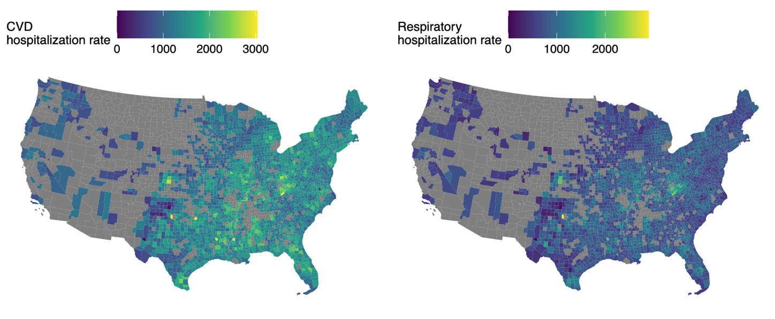**A. B.**

**C.**

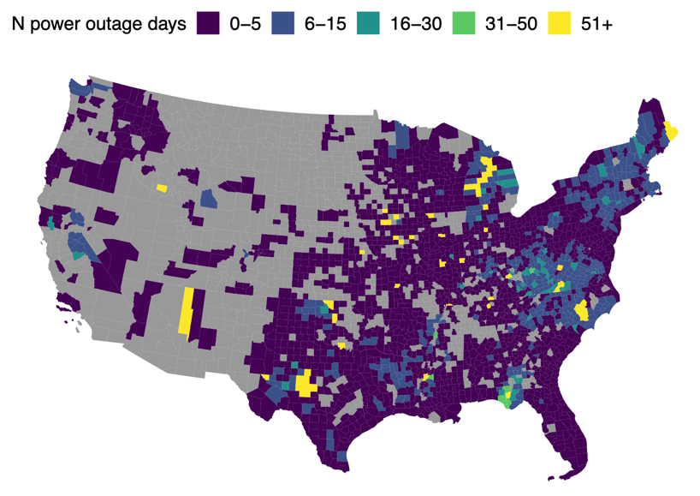

**Figure 1.** US county-level hospitalization rates and power outage counts in 2018 in the 2,161 counties included in main analysis.

**A**. Medicare Fee-For-Service county-level cardiovascular hospitalization rate per 10,000 beneficiaries.

**B**. Medicare Fee-For-Service county-level respiratory hospitalization rate per 10,000 beneficiaries.

**C**. Number of power outages in 2018.

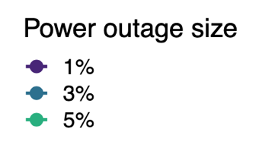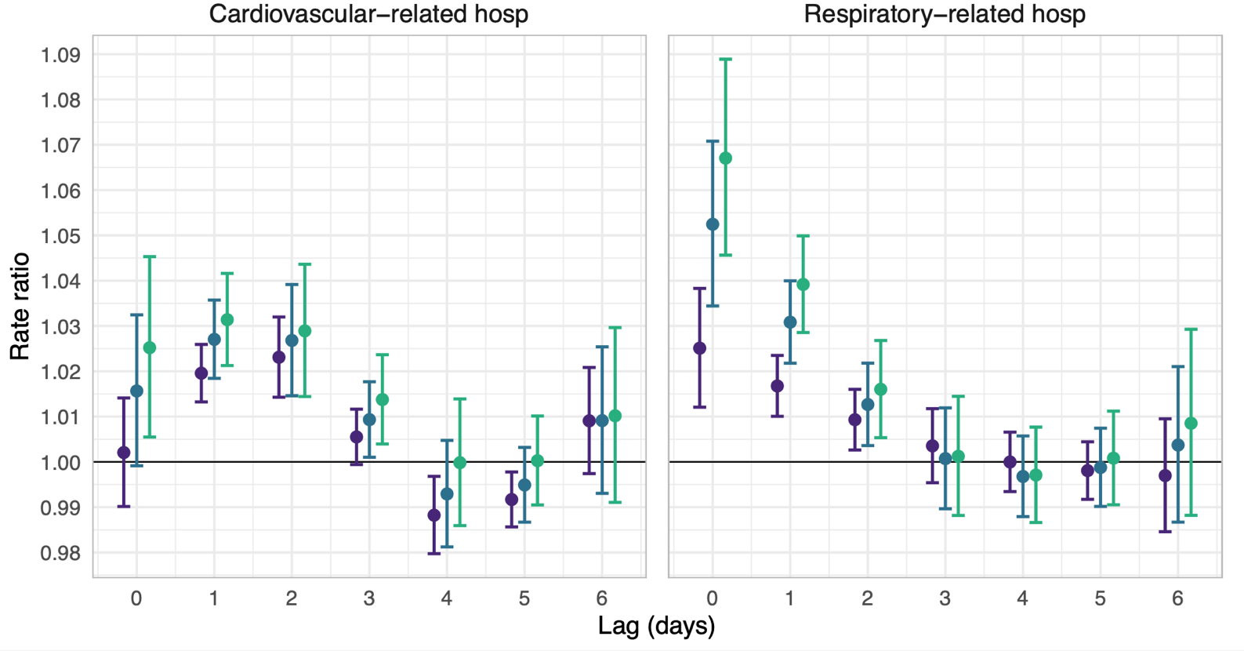**Figure 2.**

≥ 1%

≥ 3%

≥ 5%

**Figure 2.** Rate ratios and 95% confidence intervals for the association between county-level 8+ hour power outage exposure and cardiovascular- and respiratory-related hospitalizations in US 2018 Medicare Fee-For-Service beneficiaries for outages affecting ≥1%, ≥3%, and ≥5% of county electrical customers. Estimates are from conditional Poisson regression models adjusted for daily wind speed, temperature, and precipitation.

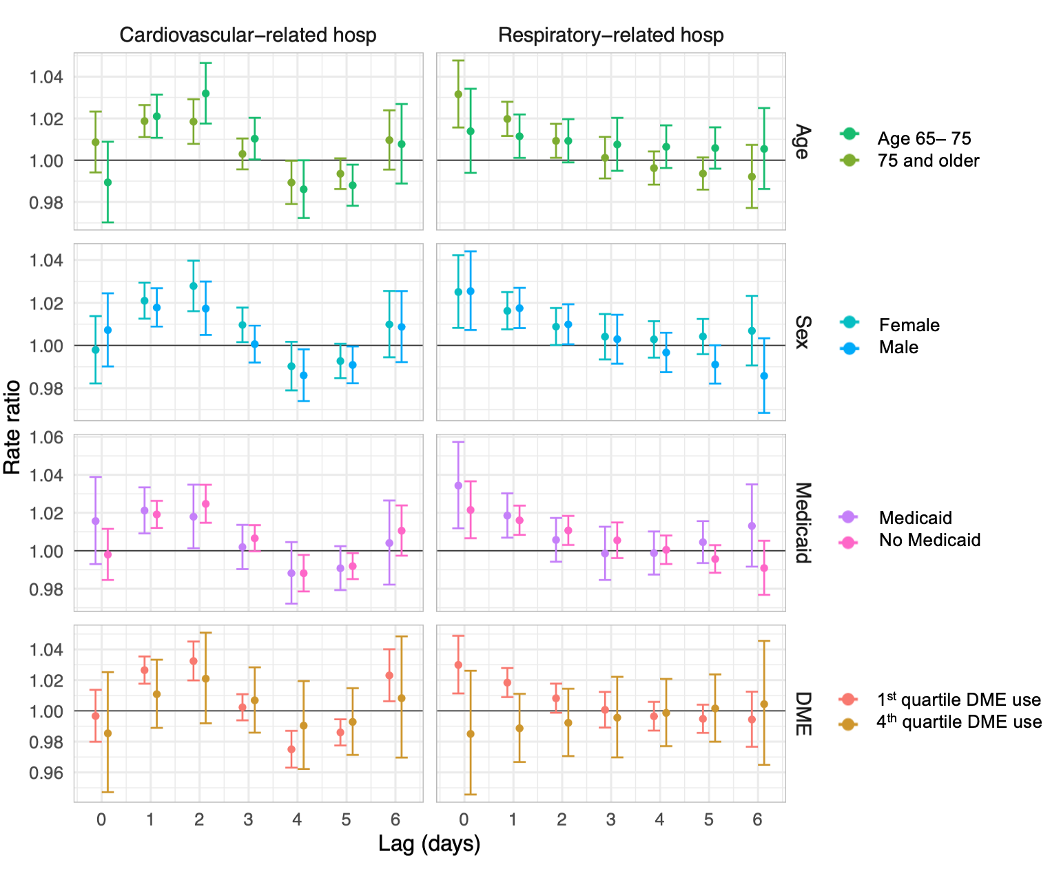**Figure 3.**

**Figure 3.** Rate ratios and 95% confidence intervals for the association between county-level 8+ hour power outage exposure and cardiovascular- and respiratory-related hospitalizations in US 2018 Medicare Fee-For-Service beneficiaries for outages affecting ≥1% of county electrical customers, stratified by potential effect modifiers: age, sex, dual-Medicaid eligibility, and county-level durable medical equipment (DME) use quartile (1st quartile = <0.5%, 4th quartile = >0.8%). Estimates are from conditional Poisson regression models adjusted for daily wind speed, temperature, and precipitation.

**Table 1.** Distribution of power outages by 2018 Medicare Fee-For-Service study population sociodemographic characteristics.

|  |  |  |  |
| --- | --- | --- | --- |
| **Number of county beneficiaries by category** | | | **Mean percent of county-person-days with 8+ hour outage affecting ≥1% of county customersa** |
| **All** | |  |  |
|  | | 23,645,101 | 1.3% |
| **Sex** | | | |
|  | Male | 10,824,475 | 1.3% |
|  | Female | 12,820,626 | 1.2% |
| **Age, years** | | | |
|  | 75 or older | 9,794,477 | 1.3% |
|  | 65 - 75 | 13,850,624 | 1.2% |
| **Medicaid eligibility** | | | |
|  | Eligible | 2,620,107 | 0.8% |
|  | Not eligible | 21,024,994 | 1.7% |
| **County-level Medicare beneficiaries using durable medical equipment** | | | |
|  | Quartile 1 | 14,204,467 | 0.8% |
|  | Quartile 2 | 5,347,182 | 1.7% |
|  | Quartile 3 | 2,670,518 | 2.0% |
|  | Quartile 4 | 1,422,934 | 2.0% |

a mean{total person-days exposed in each county / total person-days in study period in each county} for each category (male/female, 65-75, etc.)